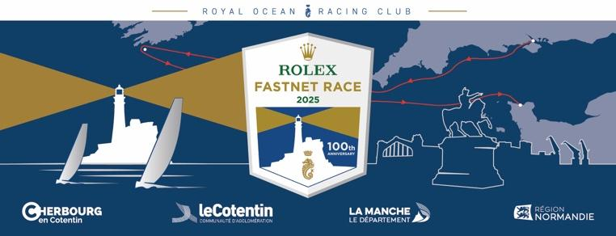

**UK PRESS STORY LEADS**

**2025 ROLEX FASTNET RACE**

Notes on just a few of the boats in the record-breaking fleet taking part in this year’s race (as @ 080725)

**CONTENTS:**

Page 1 Buckinghamshire, Channel Islands

Page 3 Cornwall

Page 4 Devon

Page 5 Hampshire

Page 1- Isle of Wight

Page 11 Lincolnshire, London

Page 12 Suffolk

Page 13 Surrey, Sussex, Northern Ireland

Page 14 Wales, Ireland

**We have more stories on teams from several other counties, so please just let us know how we can help. If you want interviews or contact with competitors from your country/region, please email:** [**press@rorc.org**](mailto:press@rorc.org) **and we will be happy to help.**

**BUCKINGHAMSHIRE**

**First time round for thrill-seeking Sisterblysse**

*Sisterblysse, Jeanneau 389, Palle Hansen – IRC4*

Home port: Port Solent

Yacht Clubs: RORC, Port Solent Yacht Club

Built in 2016, Sisterblysse was bought from new by Palle Hansen and his wife (Milton Keynes, Bucks), and was a Sunsail charter boat for the first 4 and a half years of her life. She was kept in the Caribbean for a further two years, before sailing back across the Atlantic to the UK in Spring 2023.

“We’re here for the thrill, the challenge and the history,” say Palle, who is competing in the Fastnet for the first time. He started sailing in 1992 in Copenhagen, Denmark and says his biggest achievement so far was crossing the Atlantic West to East in 2023: “a steep learning curve, which helped me immensely to prepare for long ocean races.” The rest of the crew is made up of a couple of friends, and people who met at the bar at RORC Clubhouse in London and on social media sailing groups.

The crew have varied jobs:- driving instructor, banker, painter and decorator, student, computer system architect, computer game developer and building site agent.

Palle adds: “Just saw there is 104 registered boats in IRC 4 class, would be delighted to beat them all! Or at least try to! On a serious note, expectations are, first of all, to get to the finish line, and try and cope with whatever the race will throw at us!

“To compete in such a long ocean race with so many competitors will be quite exciting.”

**Contact: Palle Hansen - Palle@sisterblysse.com**

**CHANNEL ISLANDS**

**Two’s company for Guernsey husband and wife first timers**

*Seventh Sun, Sunfast 3300, Richard Stapley*

Guernsey – IRC3

Yacht Clubs: Guernsey Yacht Club, Royal Channel Islands Yacht Club

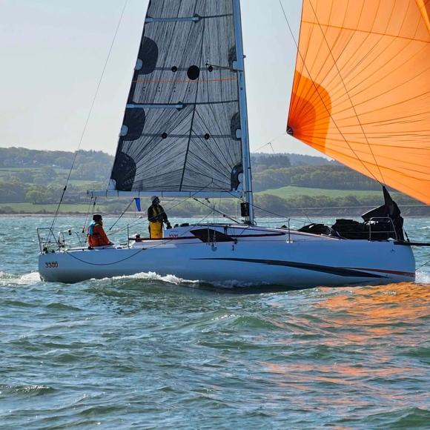

Husband & wife team, Carol-Anne & Richard Stapley, have 30 years’ experience of various race/cruising boats, but are both sure that it will be a huge challenge to complete the Fastnet double handed. Seventh Sun was purchased new at the end of 2022.

The accountants from Guernsey commented: “It’s just the 2 of us, Mr and Mrs! It’s going to be very tough, but we know our boat inside out, and have sailed various boats together for years so are quietly confident that we won’t be last :)”

Husband Richard added: “First and foremost, we want to finish safely, in one piece, and have a memorable experience. We won’t win anything, but I’d secretly like to think that we can finish midfleet.”

“The start will be epic and this is the first challenge to get over safely. Then, negotiating the tides around Alderney. We’re looking forward to getting properly offshore in the Irish Sea and rounding the Fastnet Rock.”

**Instagram @richard.stapley.3**

**Contact: Richard Stapley -** [**rs@richardstapley.com**](mailto:rs@richardstapley.com)

**CORNWALL**

**Brain injury survivor makes headway back to professional sailing**

*Black Dog VI (Kernow Ocean Racing), Class 40, Robin Elsey-Webb*

Falmouth

Falmouth-based skipper Robin Elsey-Webb is grateful to be back on track and pursuing his offshore racing ambitions, after recovering from an horrific brain injury and broken neck in 2023.

Now working on a new Class 40 campaign, alongside Stuart Sawyer, aiming for the 2026 Route du Rhum, they will be doing the RORC IRC double handed events and the Fastnet in Class 40.

The project, Kernow Ocean Racing, not only focuses on competitive racing, but also supports **Headway UK** **to raise awareness and fund for brain injury survivors**: [www.justgiving.com/page/robinelseywebbfastnet2025](http://www.justgiving.com/page/robinelseywebbfastnet2025)

Robin, who recently featured in a BBC Life Changing podcast ((<https://www.bbc.co.uk/programmes/m002>) says:

“It’s a huge step back into offshore racing—and one I don’t take for granted. As part of this project, I’m raising money and awareness for Headway UK, the brain injury charity. At the time of my injury, we didn’t know about them—but they could have made a real difference. I want to make sure others in similar situations know they exist, and know they’re not alone. Headway does incredible work supporting people through life after brain injury.

I also want to show that there is life after brain injury. It might be different, but it’s still full of potential. You can still achieve your goals—whatever they may be.”

To follow Robin and Kernow Ocean Racing: <https://www.facebook.com/robinkernowoceanracing/>

**Big step up for Cornish racing crew**

*Afrita, Sigma 33 OOD, Andrew Laming – IRC4*

Falmouth

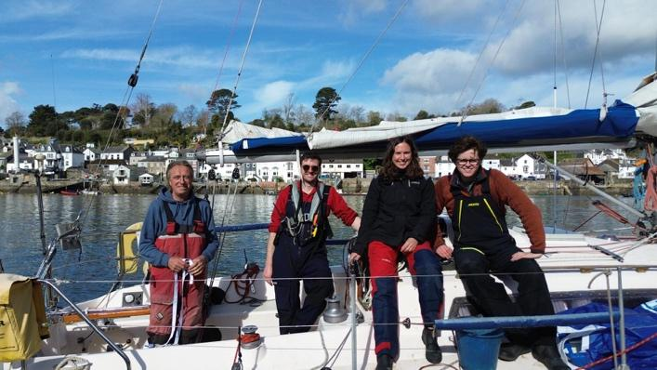Yacht Club: St Mawes Sailing Club

1979 built, Afrita is one of the first of this classic David Thomas design.

Andrew Laming describes how he first got into sailing:

“First time, I started in a Mirror dinghy we bought to go fishing, but we pulled the sails up and never went fishing again. Got into racing it, then Graduate dinghies at University of Keele Sailing Club. I got into big boat sailing via Farr 40s with a friend's group, and on another friend's GK24. After a feisty coastal race we had to retire from, I thought I want to do more of this and bought my own boat.”

The crew is a group of friends who race round the cans regularly. Rory Thompson, Lydia Paleschi and Jack Wellings, are all British from Falmouth. They are 24, 28 and 32 years old with relatively little experience offshore, other than some of the COGS races to Roscoff and other local night races. Rory Thompson is a design engineer with the AI robot Ameca, the robotics company based in Falmouth.

Andrew describes their hopes for the race: “Overall, we just want to finish, be competitive in our class, to have an enjoyable race. The challenge will be making it to the bar in Cherbourg with my fantastic crew. It will be a big moment for all of us, a big step up from the offshore racing we have done before.”

He views the key challenges as: “Leaving Land’s End behind and heading out to the Rock with a judgment call on the forecast in a relatively slow boat with a long way to go. I've sailed to Cork a few times, but not under race conditions. The biggest challenge is keeping pushing for the duration of the race, and keeping the crew safe. Get back in one piece hopefully doing well in the race.”

Highlights for the crew will be: “The spectacle leaving the Solent, the race's reputation, the challenging weather in this part of the world….The Needles, the Rock and passing our home port along the way.”

**Onboard reporter: Lydia Paleschi, +44 7904 795085**

**Contact: Andrew Laming -** [**andrewlaming1@gmail.com**](mailto:andrewlaming1@gmail.com)

**DEVON**

**First zero fossil-fuel, biocide-free yacht in Fastnet**

*Nasca, Contessa 34 OOD 2.01, Wayne Peters – IRC4*

North Devon

In this record-breaking fleet for the centenary edition of the Fastnet, history willbe made once again because for the first time, a yacht is taking on the 695-mile challenge without taking a single drop of fossil fuel with her… SV Nazca is setting out to be the first-ever zero fossil-fuel, biocide-free yacht to compete in the Rolex Fastnet Race.

A 40 year old upcycledContessa 34 OOD, owned and skippered by Wayne Peters, her crew are all adventurers and ocean advocates who are sailing to give the ocean a voice, and inspire future generations of sailors to become stewards of the seas.

Nazca is an ambassador for the [Ocean Conservation Trust](https://oceanconservationtrust.org/) and [Seaful](https://seaful.org.uk/), a UK charity helping more people to reconnect to the ocean and waterways, for their mental health benefits, and to nurture stewardship of our blue spaces.

Wayne is part of a group that, over the years, has facilitated the modernisation of a fleet of racing and cruising yachts, in collaboration with principal technology partners; Oceanvolt in Finland and Victron Energy in the Netherlands. These yachts have sailed thousands of ocean miles around the world, with minimal impact on the ocean.

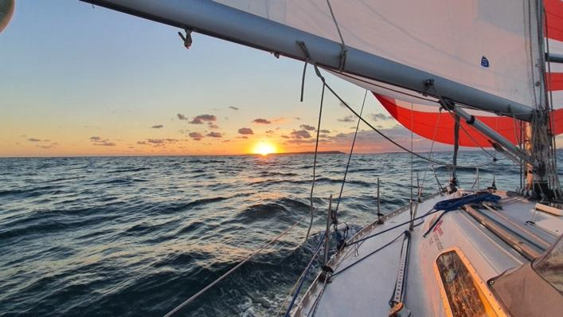

As Wayne Peters comments: “The Fastnet race has always been a test, but the real unease in me is knowing that the ocean is restless, the storms seem bigger, more frequent, the wind shifts are more aggressive. Last edition’s Fastnet start was a brutal reminder of how conditions can change quickly, and even the most seasoned offshore sailors had their fair share of problems, before they'd even left the Solent.

Thinking about this year’s race, Wayne says: “Apprehensive? Definitely. I trust the boat, the method, the crew and the kit, but this is where we are going to find the limits. The Fastnet forces us into the unknown, the unpredictable and the uncontrollable. And that’s why it matters.”

[**https://foroneocean.org/**](https://foroneocean.org/)

[**https://oceanconservationtrust.org/**](https://oceanconservationtrust.org/)

**https://seaful.org.uk/**

**Contact: Bee Woodland -** [**beetoosea@gmail.com**](mailto:beetoosea@gmail.com)

**Easy as for Corinthians on Easytiger**

*Easytiger, Catamaran Dazcat D995, Neil Boughton*

Plymouth

Yacht Club: Royal Western YC and Royal Naval Sailing Association.

Originally completed as an open bridge deck cat, Easytiger was converted to an enclosed bridge deck by Multimarine, who originally designed and built the hulls in 2014. This will be the first time round the rock for owner/skipper Neil Boughton, who competed in the Round Ireland race in 2024, coming a respectable 3rd in challenging conditions.

This Corinthian team, who race together on and off, mainly round the cans and coastal or cross channel races, have a good blend of athletic ability and experience, with 2 members under 30 and 2 over 60. They also come with impressive naval pedigree: One retired university lecturer, one semi-retired (teaching Met and Oceanography at BRNC (Britannia Royal Naval College)), a naval architect and watch keeping officer for MSC cruises.

**Contact: Neil Boughton -** [**neil690m@gmail.com**](mailto:neil690m@gmail.com)

**HAMPSHIRE**

**Military crew returns to Fastnet aboard Trojan for leadership under sail***Trojan, J/109, Lt Col Murray Smith, UK,*UK - IRC  
Yacht clubs: Royal Engineer Yacht Club

Trojan is a 2001-built J/109 campaigned by the Royal Engineer Yacht Club, with a mission that goes well beyond results. For this team of serving soldiers, the Rolex Fastnet Race doubles as a powerful leadership development tool – honing decision-making, teamwork, and resilience under pressure.

“To develop soldiers – we use the race as military leadership training,” explains Lt Col Murray Smith, skipper of the campaign. The 2025 edition will also see the team match up against other military crews, with a clear focus on inter-service competition as well as personal growth.

Every member of the crew serves in the British Army, with roles ranging from bomb disposal officers and parachutists to armoured engineers – bringing a level of calm, coordination and discipline that’s right at home offshore.

Their main goal for this year? To finish strong and get to Cherbourg without incident. “The 2023 race was a real slog due to multiple boat breakages,” Smith recalls – making the final destination an even more welcome target this time around.

Social Media:  
Instagram: @reycoffshoreracing  
Contact: Email: [offshore@sappersailing.org](mailto:offshore@sappersailing.org)

**Darkwood aims to build on solid 2023 performance***Darkwood, J/121, Michael O'Donnell, Hamble,*UK - Class 1  
Yacht clubs: RORC, RYS, RTYC

Darkwood, a J/121 launched in 2019 by J Boats in Rhode Island, is back for another run at the Rolex Fastnet Race. Skippered by Michael O'Donnell, the boat races under the Irish flag and is based out of Hamble, with affiliations to RORC, the Royal Yacht Squadron, and the Royal Thames Yacht Club.

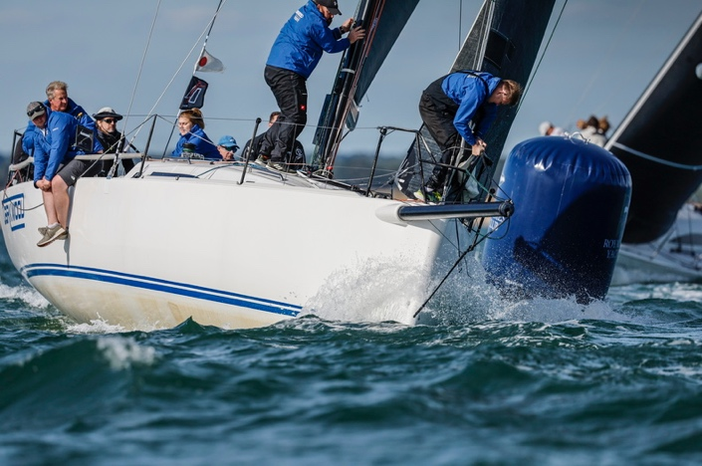In the 2023 edition, Darkwood finished a respectable 9th in class. This year, the crew are aiming to go one better — their focus is on executing a clean race and improving on last year’s performance. “Get round the course, match or improve on 2023,” says O'Donnell.

And when it’s all said and done? “A cold beer in Cherbourg with my crew” is top of the list.

Website/Socials: Facebook: Darkwoodracing

**First racing season for Conspiracy after major refit**

*Conspiracy, Club Swan 42, Ray Mitchell – IRC1*

*Lymington*, Hampshire

This is owner/skipper Ray Mitchell’s first season racing Conspiracy, having just completed a major refit after shipping her over from Newport, RI. She was the first Club Swan 42 built for the Commodore of the New York Yacht Club in 2016.

Ray’s last Fastnet was in 1995, so he’s looking forward to taking part in the race again, after a lifetime of racing various boats, including Contessa 32, Swan 41, 45 & 46, along with J24, J80 Etchells & Nordic Folkboat. His crew is made up of a group of friends, some of whom own and race their own boats. Professions onboard include a solicitor, an insurance broker, a property investor and a surgeon.

Ray comments: “If it's a strong SW wind, then the first leg to Land’s End will be a challenge. A fast downwind leg to the finish would be nice!”

**Contact:** [**ray.mitchell@sullivanmitchell.co.uk**](mailto:ray.mitchell@sullivanmitchell.co.uk) **Next generation crew lines up for Fastnet aboard Astrid***Astrid, S&S Swan 44, Patrick Moriarty, Hamble,*UK - IRC4  
Yacht clubs: RORC, FFSC

Built in 1972 and lovingly restored for the 2025 season, Astrid is a timeless Swan 44 — a design originally created for the Admiral’s Cup, though this particular boat never competed in it. Now, more than fifty years after she first hit the water, Astrid returns to top-flight offshore racing with a new mission and a fresh, energetic crew.

Skipper Patrick Moriarty, from Bury St Edmunds, will be racing alongside a crew made up entirely of recent university graduates — including his brother, Thomas Moriarty, who owns the boat. “Our main aim is to complete the race safely,” says Patrick. “If we can do well in our class, that would be brilliant.” The team is particularly excited about the milestone moment of rounding Fastnet Rock — a challenge that’s inspired generations of offshore sailors.

The young, diverse crew brings enthusiasm and growing experience to the task. Navigating and tactics will be handled by Thomas Gurney from Plymouth, while William Wilkinson takes the bow. The pit is manned by Oscar Ballentyne, who hails from both the UK and Sweden, with Charlotte Wakefield working mid-bow and Nular Sellwood trimming. Connie Stevens handles mainsheet duties, while helm responsibilities are shared with Harry White of Cowes and Perdy Light, also from Cowes.

Together, they represent a new generation embracing the spirit and challenge of one of the world’s greatest offshore races. With a vintage yacht, fresh ambition, and a love for the sea, Astrid is ready for a memorable test in the Rolex Fastnet Race.

Website/Socials: <https://www.instagram.com/sailing_yacht_astrid>

**Unfinished business for returning crew, the McGoughs, aboard Just So***Just So, J/109, William McGough, Lymington,*UK - IRC Overall, IRC 4 & IRC 2H  
Yacht clubs: RORC, JOG, RLymYC

The 2025 Rolex Fastnet Race will see Just So, a well-raced J/109 based in Lymington, back on the start line after previous attempts in 2019 and 2021 ended in retirement. The boat has been in the McGough family since she was launched in 2007, and this year she returns with William McGough at the helm, sailing in the doublehanded division.

Entered in IRC Overall, IRC 4 and IRC 2H, Just So is a familiar sight in UK offshore sailing, regularly competing through clubs like RORC, JOG, and the Royal Lymington Yacht Club

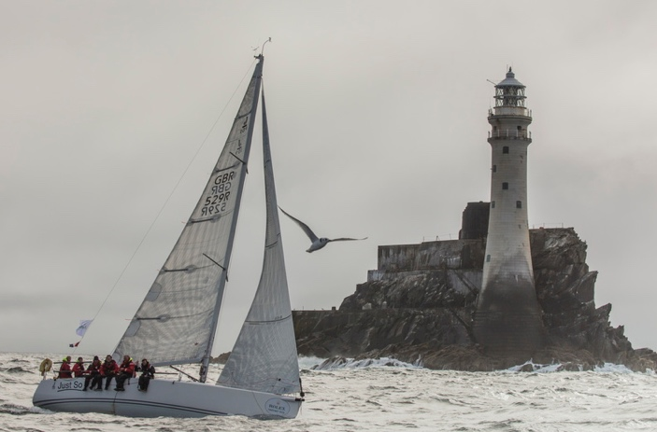

The ambition this year is modest but heartfelt: “Our main goal is to finish!” says McGough. For crew member Christian, the motivation is especially tangible — he’s been saving himself for a first beer in six months, waiting for that moment on the dock in Cherbourg.

With no corporate campaign or curated media push, Just So continues to embody what the Fastnet is all about for many teams: personal goals, shared experience, and the quiet satisfaction of crossing the line.

**Royal Navy team sails to race, reflect and represent***Sovereign Sail Navy (SSN), Sun Fast 3600, RNSA, United Kingdom,*UK - IRC  
Yacht clubs: Royal Naval Sailing Association

Built in 2018 and acquired by the Royal Naval Sailing Association in 2022, Sovereign Sail Navy (SSN) is more than just a boat — it's a platform for developing leadership, resilience and teamwork under sail. Funded by generous support from the Royal Navy Royal Marines Charity (RNRMC) and the Royal Navy Royal Marines Sports Lottery (RNRMSL), SSN is one of the latest assets in a longstanding effort to develop competitive sailing within the Armed Forces.

The team is drawn entirely from serving members of the Royal Navy and Royal Marines, and for them, the Rolex Fastnet Race is as much about testing character as it is seamanship. “We believe creating a successful offshore sailing team pulls on the Royal Navy values in a uniquely beneficial way,” says the team. “Courage, commitment, discipline, respect, integrity, loyalty — they’re not just values for the service, they’re the foundation of good sailing.”

Expectations are set high from the outset. “We advertise it as a challenge,” they explain. “You’ll probably be wet, cold, tired and hungry — and hopefully also enjoy some amazing racing. This race is addictive. There’s a strong chance you’ll want to do it all again.”

That sense of purpose and personal growth is central to the crew’s motivation. “The teamwork needed to complete this race is tremendous. Leaving sight of land at sunset, knowing it’s you and your team who will deal with whatever comes next — that’s a powerful feeling.”

The 2025 SSN crew will include a significant female contingent, with around 30% of the team expected to be women — continuing the push for increased inclusivity across offshore sailing.

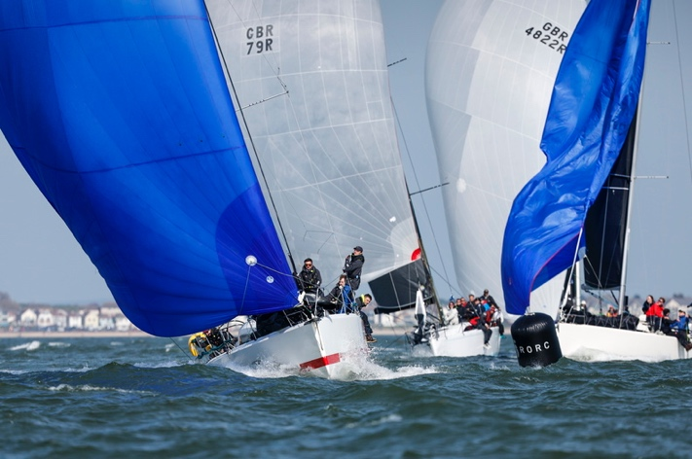 Website/Socials: [www.rnsa.org.uk](http://www.rnsa.org.uk/)#RoyalNavySailing #SailTogether  
Contact: Phil Warwick, RNSA - ceo@rnsa.org.uk

**Generation JOG fuel Jetpack**

*Jetpack, JPK 10.10, Mark Brown*

Gosport, Hampshire

Yacht Clubs: JOG, RORC

This will be Mark Brown’s seventh Fastnet, his fourth as skipper, and his first on board the JPK 10.10, only acquired in 2022. She is a 2016 yacht, and was based in Guernsey until 2023. His crew are wholly Corinthian, all friends and acquaintances who have bonded over their mutual love for the sport:

Mark Brown (Gosport) - skipper

Sam Jones and Matt Latlaud (Derby) - nav and trim

Mark Stevens (Reading) - helm and trim

Emma James (Poole) - helm and trim

“Mainly young crew from Generation Jog, we have all sailed together for 2 years, and some up to 8 years together. In navigator Sam (Jones), we trust!”

Their secret weapon may stem from all the crew having solid dinghy backgrounds, “so all the crew can trim and helm – there are no passengers!” claims Brown.

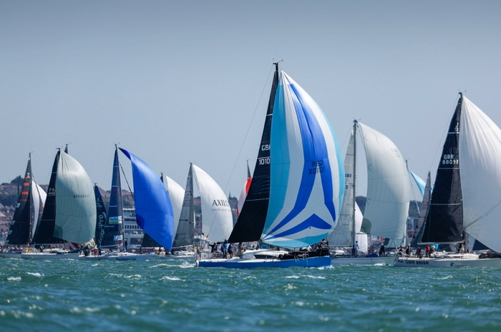Their key aim this year will be to complete the race, unlike the last edition, when they ripped a sail in the first 5 hours. Ideally, they’ll be looking for “Top 3 in class, overall is a lottery.”

Highlights will be: “Steak and chips at the end! Before, it’s just a hard course and nav needs to be spot on.”

**Contact: Mark Brown -** [**Fourseasonscharter@icloud.com**](mailto:Fourseasonscharter@icloud.com)

**Amateur sailors strive for success**  
*Musketeer II, Contessa 32, Gavin Lockhart-Mirams*

*Andover, Hants – IRC4*

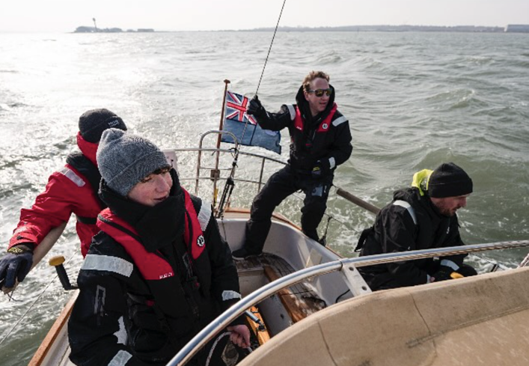 “Our class is attracting an extraordinary group of boats (and people), and our Contessa 32 Musketeer II (with all the Fastnet heritage) is one of them.

“We are racing for the first time with a crew ranging from 14 (my son) to 65 (an Australian who has crossed the Atlantic twice). I think it is testament to how the race brings people together to strive for amateur success.”

[https://www.instagram.com/sailmusketeer2/?igsh=ZTh1MGZrc2R6dzM1&utm_source=qr#](https://www.instagram.com/sailmusketeer2/?igsh=ZTh1MGZrc2R6dzM1&utm_source=qr)

**Camaraderie among Corinthians on Jumunu**

*Jumunu, J/109, Lesley Brooman – IRC4*

Swanwick, Hampshire

Yacht Clubs: JOG, QMSC, Carrbridge SC, Oxted Offshore SC, RORC

Jumunu was built in 2004 and Lesley Brooman (Faversham, Kent) is her third owner. Lesley has previously taken part in six Rolex Fastnet races, two in her own boat.

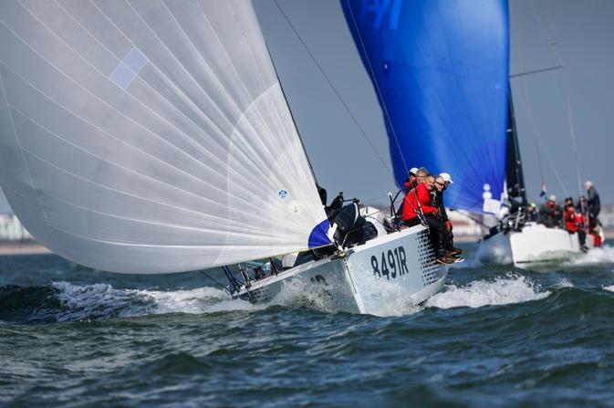

She started off dinghy sailing in the Thames Valley, then progressed to coastal dinghy racing events, in her own boat. She has been coastal and cross-Channel racing since 1992, in her own boat since 2016. As well as the Fastnet races, she has competed in 2 Caribbean 600 and one Middle Sea race, as well as the RORC Round Britain & Ireland in 2000.

The rest of the crew is made up of friends, all Corinthians, who like long-distance offshore racing and the camaraderie of working together as a team. Their hope is “to finish, preferably in the top half” and for “better weather!”

**Contact: Lesley Brooman - lesley.brooman@gmail.com**

**Sail Racing Academy fields two boats united in adventure and passion for sailing**

*Escapado & Venturoso, Beneteau 40.7/Beneteau 40, Southampton/Hamble – IRC3 & IRC2*

Escapado was built in 2008 and was the vessel that started Sail Racing Academy. She finished first in class in Antigua Sailing Week in 2024, and was the 2022 winner of the ARC Racing Division.

Venturoso was built in 2009 and is the most recent addition to the SRA fleet, having joined in October 2024. She had a successful first season in the Caribbean, racing in the Caribbean 600, Heineken Regatta, BVI Spring Regatta, and Antigua Sailing Week.

Sail Racing Academy was founded by Germaine Williams with a simple but powerful mission: to open the world of sailing to people who might not otherwise have the opportunity. SRA is a platform to make sailing more accessible, inclusive, and adventurous. Whether someone’s completely new to the sport or looking to gain offshore miles, Germaine brings together a diverse crew of sailors from all walks of life and gives them the chance to be part of something extraordinary.

Our aim is to bring together a diverse crew from all over the world and turn that mix of backgrounds and experience into a united, high-performing team. We’re expecting a challenging but rewarding race, where everyone—whether seasoned offshore sailor or first-time Fastnet competitor—comes away having grown in skill and confidence. We’re here to race hard, learn from each other, and enjoy every bit of the adventure the Fastnet has to offer.

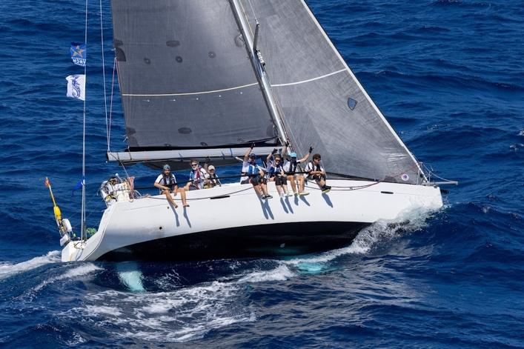

The SRA’s Chief Operations Officer, Anne Tyler Morgan, describes the appeal of the Rolex Fastnet Race: “It’s iconic. The blend of history, international competition, and sheer variety in conditions and tactical challenges makes it one of the most respected offshore races in the world. It attracts top-tier sailors, but also keeps its arms open to passionate amateurs. It’s tough, beautiful, and utterly addictive. The Solent start is chaos and excitement in equal measure, then you get the drama of rounding Portland Bill and the long push past Land’s End. But the crown jewel is rounding Fastnet Rock—it’s a breathtaking moment that makes all the hard sailing worth it. And finishing in Cherbourg gives the race an extra international flair that rounds it all off perfectly.

Escapado has taken on the Fastnet challenge twice before, making this her third. This will be Venturoso’s first time racing in the Rolex Fastnet with us, but as a company, we’ve participated twice before.”

**https://www.sailracingacademy.org/**

**Contact: Anne Tyler Morgan Anne@SailRacingAcademy.org**

**+44 7465620258**

**Tall Ships Youth Trust fields 2 youth campaigns for second year**

*Challenger 1 & 3, Challenge 72OD 3.20***,** *Tall Ships Youth Trust,* Portsmouth – IRC1

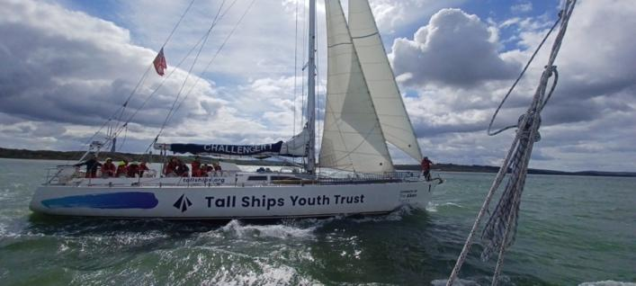

Following on from their 2023 race entry, the Tall Ships Youth Trust is once again fielding two of their iconic 72ft Challenger yachts, which will compete with mixed crews of 16 young people and 8 sponsoring adults.

In 2023, they tackled one of the most challenging first 24 hours of racing in recent Fastnet history and completed the 700nm course in 05d 02:18:15.

Building on this achievement, TSYT has developed an exciting new ocean racing pathway for young people, to align with its [three-voyage journey](https://tallships.org/what-we-do/a-young-persons-journey/)of Exploration, Empowerment and Leadership. Their aim is to break down barriers in sailing through creating the ultimate challenging environment while racing on the ocean, enabling ambitious young people, who wouldn’t otherwise have the opportunity, to take part in one of sailing’s most prestigious global events.

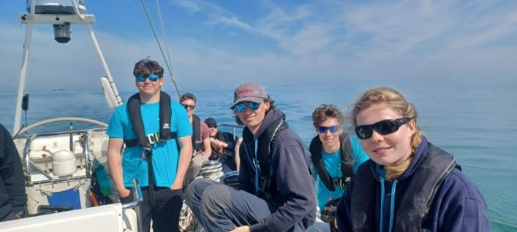

Out on the ocean, TSYT empowers young people to realise their full potential, supporting them on their journey to adulthood and, for some, into careers in the maritime sector and the blue economy. They operate four iconic 72ft Challenger yachts, enabling young people aged 12-25 from across the UK to develop life and career skills through sailing, while building self-esteem and embracing a healthier, more active lifestyle.

Eva Murphy, TSYT 2025 Fastnet youth crew member told us: “*I live a long way from the sea, and to have these opportunities to go down to Portsmouth for the Fastnet crew selection and sail, has been amazing. I want to follow a career in sailing, this will be an incredible base to help me in my next step. Sailing is all about the challenge, and Fastnet is going to be the biggest challenge so far for me. I’m excited to push myself and see if I can do what’s not possible for so many others*”.

At a crew training weekend in March, adult crew member Simon Haynes commented:

*“I’m mostly interested in meeting the young folks who are involved in this, listening and learning more about their backgrounds. As a parent myself, it’s fascinating to see how enthusiastic they are, and I’m looking forward to seeing how they develop throughout the challenge”.*

Alastair Floyd, CEO of Tall Ships Youth Trust, added:

*“We’re thrilled to be a part of the 2025 Rolex Fastnet Race. We have entered two mixed crews of young people and adults so that they can learn from each other and optimise their experience. Adventurous racing opportunities like the Fastnet are a key part of our brand-new ocean racing programme, where we are working hard to break down barriers in sailing and help young people kickstart their racing journey”.*

*(NB: An additional boat -Challenger 4 has been privately chartered)*

[**https://tallships.org/**](https://tallships.org/) **For more information on how to support these young sailors:** [tallships.org/appeal/ocean-racing-and-fastnet-2025/](https://tallships.org/appeal/ocean-racing-and-fastnet-2025/)

Contact: Bolade Adebayo,

Digital, Engagement and Marketing Manager

**Dinghy racing friends aim to be 1st wooden boat in class**

*Old Mother Gun, Humphreys 40, Tim Penfold, Rowlands Castle, Hampshire, IRC3*

Old Mother Gun is a one-off custom boat, built in Lymington in 1989 by Neville Hutton. Her design was based on the 37ft Apriori, which was launched the year before and was very successfully raced by John Dare, the then commodore of RORC. “We want to be the first wooden boat and in the top third of our class. The most challenging part will be to make sure we finish with the boat and crew in one piece! The History of the race means this 100-year anniversary race is going to be very special and the highlights will be crossing the Celtic Sea and rounding the Rock.,” says Tim Penfold. This will be his first time as skipper, although he has been a navigator twice previously.

Tim Penfold’s sailing CV includes lots of high-performance dinghy racing including 18ft skiffs and foiling moths. He says” We are just a bunch of friends from mainly racing dinghies over the years, who are doing it for the challenge and fun.

**ISLE OF WIGHT**

**Father & Daughter team from Cowes**

*Jangada, JPK1010, Richard Palmer – IRC4*

Cowes, Isle of Wight

Yacht Club: RORC

After successfully completing the 2023 Rolex Fastnet Race together, Richard Palmer (RORC Honorary Treasurer), will once again be sailing doublehanded on Jangada (2011), “to share the experience with my daughter, Sophie Palmer. This will be the 11th Fastnet for me, and Sophie’s second.”

Past sailing highlights for Richard have been:

2022 RORC Seasons champion, Winner 2019 RORC Transatlantic & 2022 SRBI and with Sophie, 3rd in the 2019 AZAB.

Back on land, Richard is Honorary Treasurer of the RORC, while Sophie works with children with special needs. They both enjoy the diverse range of entries in the Fastnet, from newcomers to seasoned sailors, both amateur and professional.

“We will be hoping for light winds and calm seas!” says Richard, “A clean start and exit from the Solent with all the other boats is key to settling in well. It always takes 24 hours to then settle into the rhythm.”

**https://www.facebook.com/groups/jangada.racing/**

**https://www.instagram.com/jangada_racing/**

**Contact: Richard Palmer - jangada@me.com**

**Exorcising demons of 2023 becalming**

*Mzungu!, JPK10.80, Sam White (Owner), Sam North (Co-Skipper)*

Yarmouth

*Yacht Club:* JOG, Royal Naval Sailing Association

Built in 2017, but only raced in ’17 & ‘18 before ‘resting’ in Hamble Point until 2021, Mzungu! was then acquired by Tony and Sam White to compete in the RORC and JOG season trophies.

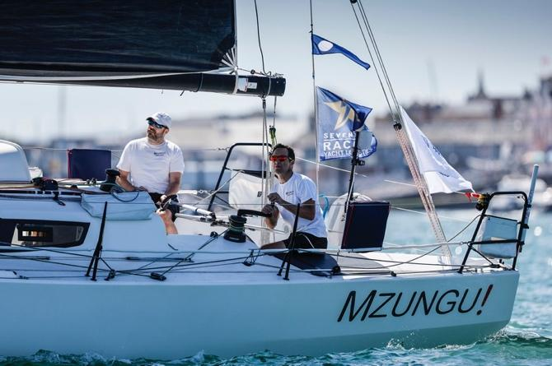

Owner, Sam White, will be joined by co-skipper, Sam North, a former professional sailor and North Sails employee (no relation!). This will be Sam White’s [7th] race, and Sam North’s [4th] race. Previous successes include:

3rd overall and 2H + 2nd overall IRC2 Round Britain & Ireland 2022, 1st IRC4 2H Rolex Fastnet 2021

2nd overall Sydney - Hobart 2000

2nd overall middle sea race 1999

RORC yacht of the year 1999

Mzungu! is run and maintained on an entirely Corinthian basis, and both co-skippers are longstanding RORC members.

Sam White is an airline pilot and property developer from Yarmouth, Isle of Wight, following a career in the Royal Navy, Sam North owns a conference and trade show business and splits his time between London and the New Forest. Their friendship goes back to university, but the idea for their 2H campaign was sparked during a beery stag do in Lake Garda in 2020! As a 2H team, they both do everything, albeit Sam White tends to run the front of the boat, with Sam North at the helm.

They will be digging even deeper than in previous campaigns in their preparations for the Rolex Fastnet, “we need to, if we’re going to wrest the 2H trophy from the French teams!”, says Sam White, “we’ll be looking for podium in IRC2 and IRC2 Doublehanded, plus more if conditions go our way, in order to exorcise the demons of 2023, where we were contesting the 2H win at the rock, before being becalmed for 5 hours…”

“Tidal strategy - particularly for the Cornish coast, Scillies out and back, and final 50 miles - will be key. We expect the adrenaline and spectacle of the start to be unmatched. The strength of the Fastnet is the depth of competition - every single place is hard fought.”

**Contact: Sam North -** [**sam_peter_north@yahoo.co.uk**](mailto:sam_peter_north@yahoo.co.uk)

**LINCOLNSHIRE**

**Classic Sparkman & Stephens returns for another chapter***Tramp of Airlie, Sparkman & Stephens Custom Build Design #2222 C2, Chris Hames, Grimsby,*UK - IRC 4  
Yacht clubs: HCA, RORC

Built in 1976 in Pesaro, Italy, Tramp Of Airlie is a rare and distinctive example of Sparkman & Stephens design, originally commissioned as an Admiral’s Cup contender for Torquato Gennari. Constructed in aluminium, she is one of only three boats ever built to this particular design – a lineage that also includes the final Prospect of Whitby for Arthur Slater.

Tramp spent her early years racing in the Mediterranean before being reconfigured below for cruising. Despite this, she still retains much of her original 1970s DNA: the flush deck, original layout, and classic lines. “We have been custodians of her for the past 27 years,” says skipper Chris Hames, “and she’s become a true part of our lives. Without being biased – to us, she sits well in the water.”

The crew is a close-knit mix of friends and family, many of whom are from Louth in Lincolnshire. Chris Hames skippers the boat alongside co-skipper Karen Hames. Joining them are Paul Rolfe, also from Louth; Mark Smith from Norfolk; Cyphas Howard; and Tilman, a German-Austrian crewmate from Scheveningen, Netherlands, adding an international flavour to the campaign.

Their expectations for this year’s race are simple but solid: “To finish with a reasonable result.” As for highlights? “The start, rounding the Rock, and the finish.”

For Tramp of Airlie, this year’s Fastnet is not about headlines or hardware – it’s about continuing the story of a much-loved classic, still doing what she was built for nearly 50 years ago.

**LONDON**

**Opportunities for all on Lutine**  
*Lutine, X55, Lloyds of London. Tim Blackstone*

Every 2 years, Lutine takes part in the Rolex Fastnet Race with its full capacity of 13 crew, plus skipper operating a 2-watch system throughout. Fastnet represents the pinnacle of the Club’s and Lutine’s sailing calendar. The intention is to develop a cohesive team who have put in a lot of sailing hours on the water together, are trained to the best of their individual abilities and who above all else, have fun and complete a life experience that not only tests them but provides enduring new relationships of a shared adventure. 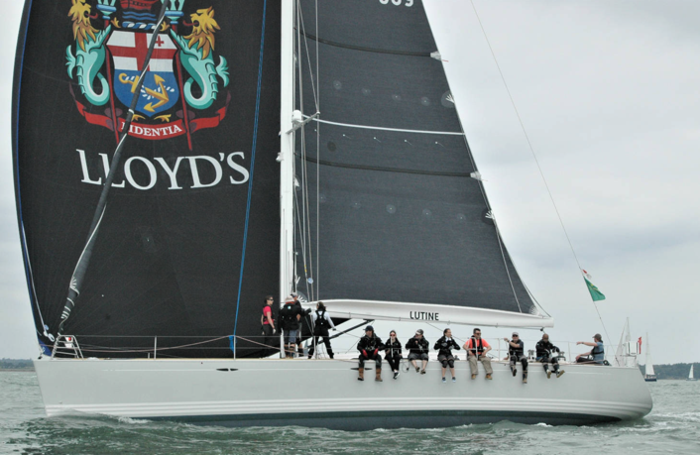

Lloyd's Yacht Club was officially formed in 1938, but in 1936, Sandy Haworth, who had joined RORC having participated in the 1935 Fastnet race, set out on an informal race from Gosport to Cherbourg – it was during their evening meal in a Café in Cherbourg that the formation of a Lloyd's Yacht Club began.

Lutine is the 5th club boats. At 55ft, weighs just 16 tonnes and has a carbon fibre rig. She is berthed at Haslar Marina in Gosport, Hants. The club’s philosophy is to make racing accessible to as many members, of all ages, as possible.

**Aiming to be the first sailing school boat in the race**  
*Cougar + Pather, Reflex 38, Ruaraidh Plummer, IRC 3*

*London*

The London School of Sailing have entered two Reflex 38s; Cougar and Panther. “I have only owned my first boat Cougar since 2023 and I’ve been sprucing her up slowly to make her a race machine,” says Ruaraidh who has competed in a five back-to-back Fastnets since 2015 (although retired in 2017). Completing on Cougar in 2023 made me realise there are hard ones and bloody hard ones!”

The school’s Reflex 38s are a Christian Stimson design, built by Harley Race Yachts UK in 1999. Both boats are racing to be the first sailing school boat in the race, as well as competing against the First 40s and other Reflexes in the race. “We are hopefully not having to stop to avoid 48 knots on the first night, like last time!”

“It would be great to pass the Rock for the first time (of what will be 6 times) in the daylight. Not to mention the satisfaction of our amateur crews coming out the other side of the endurance and having has fun. Most challenging part? Keeping the focus, mindset and drive through the tiredness, likely breakages, seasickness, and the TSS's! We will look forward to the epic atmosphere around the start, battling boats the whole way, and the finish feeling. They all make the Rolex Fastnet Race so special.”

Course highlights: “Portland Bill, Isles of Scilly, the Rock, begrudgingly the Alderney race lottery is also pretty cracking.”

Crew are all individuals from a mixture of experiences and backgrounds. The other eight have never done a Fastnet before, - for some it’s a ‘bucket list’, others a push to the next level. Many of them I have sailed with before and tricked them into signing up. My first mate is a good friend of mine Tom Holland who worked with me in Vassiliki 15 years back. Seven of the nine of us are from London. We have 1 doctor, Jon Price who is also probably the most out of his comfort zone. Also, Ben our mast man is a radiologist. Many of the crew work in tech and finance in London, and we have the designer of the Ocean Signal MOB1 beacons onboard.

Cougar Crew: Ruaraidh Plummer - Skipper/Nav/Helm, Tom Holland - First Mate/Watchleader/Helm, Neil Farmer - First Mate/Watchleader/Helm, Jon Price - Onboard doctor/trimmer, Will Grace - Pit/Bow/Trim/, Thomas Rajman - Main/Trim, Graham Lacey - Onboard fixer/Trim, Stefan Vlaski – Bow, Ben Stothard – Mast.

Panther Crew: Andy Young – Skipper, Harry McGregor – Mate, Chris Shipman - Watch leader, Angie Fenton, Charlotte Willis, Andrew Cortis, Charles Roe, Luca Arcovito, Jan Mathijs Van Rens.

Media contact: Sharon Gilleece, sharon@londonschoolofsailing.co.uk, +44 7575 424499  
  
Onboard Cougar - Will Grace - [wgrace73@gmail.com](mailto:wgrace73@gmail.com)  
Onboard Panther - Harry McGregor - [harryjmcgregor@googlemail.com](mailto:harryjmcgregor@googlemail.com)

Instagram: <https://instagram.com/londonschoolofsailing>

**SUFFOLK**

**Family crew from UK’s East Coast return to Fastnet aboard Sunstone***Sunstone, 39’ Sparkman & Stephens one-off, Will Taylor-Jones, Royal Harwich,*UK - IRC 4  
Yacht clubs: Royal Harwich Yacht Club

Built in 1965 by McGruers on the Clyde, Sunstone is a true classic – a Sparkman & Stephens one-off design with a remarkable pedigree. For many years she was campaigned with great success by the Jackson family, who not only raced her extensively but also lived aboard while cruising around the world, eventually reaching New Zealand’s South Island.

In 2021, Sunstone was brought back to the UK by current owners Jenny and Will Taylor-Jones. After an initial season of cruising, they returned her to race trim and now campaign the boat from the UK’s East Coast – with a crew made up of family and friends.

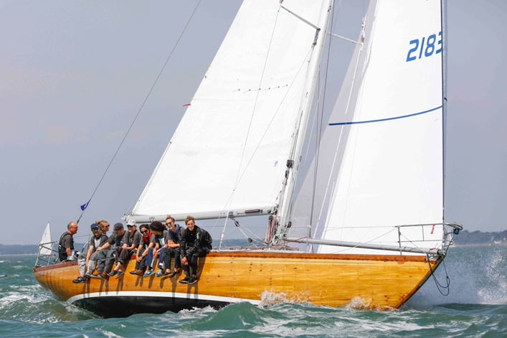The 2025 Rolex Fastnet Race marks an important milestone. The team had to retire in 2023, so this year the goal is clear and heartfelt: to finish. “That’s our primary aim,” says skipper Will Taylor-Jones. “This race is a chance to do what we love, on a boat we love, with the people we love.”

The crew for this year’s race includes Will Taylor-Jones (Skipper), Jenny Taylor-Jones (Navigator/helm), Tom Taylor-Jones (Tactics/helm), Issy Taylor-Jones (Mast/bow/helm), Sam Taylor-Jones (Mast/cockpit), Simon Brown (Bow/mast/cockpit/helm), and Matt Glossop (Cockpit/helm/entertainment officer).

One of the biggest highlights? “Racing the boat with both our children – Sam and Issy – my brother Tom, and some other great friends.” With three generations aboard and deep ties to Sunstone’s story, it’s a crew sailing for more than results.

**SURREY**

**Competitive doublehander vying for class win**

*Cora, Sun Fast 3200, Tim Goodhew – IRC4*

Leatherhead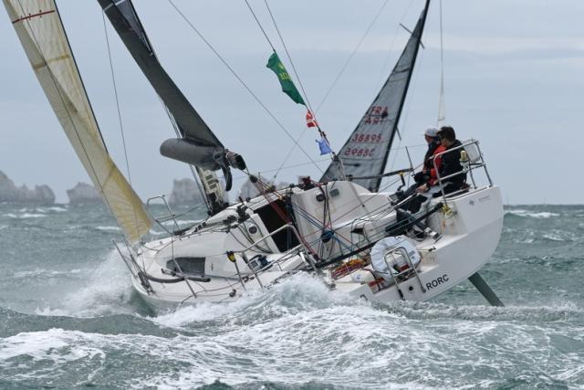

Cora is a 2008 build that has been campaigned in the RORC offshore season since 2018 - chalking up numerous race wins in class (IRC4 or IRC3 depending on the rating band each year). IRC class winners in the RORC Seasons Points Championship in: 2021, 2023, 2024.

Tim Goodhew has had a successful sailing partnership with Kelvin Matthews from North Sails since 2020, becoming 4x winners of UK Double Handed Series (2021-2024) & Double Handed National Champions 2023. Although they operate a low budget campaign, they aim to be as competitive as possible, while sailing a 15+ year old boat and mixing it with the better funded teams.

Tim has been RORC racing since 2005, as a 15 year old, with his first Fastnet in 2007. This year’s race will be Tim’s ninth, and his fifth doublehanded. Cora will be looking for a strong finish: “Our objective is to win IRC4 and IRC 2-Handed. We were very close to a class win in 2023, but let it slip in the final 5% of the race, so to finish stronger in 2025 is a key aim!

The final day has become a real challenge. You have to deal with the huge tides at Cherbourg and there are very few options to escape a foul tide. You could sail a blinder but be out of phase with the final tide and really suffer!

Often it's a broad reach back from the Rock that's a real highlight, and you feel you've earned it after a 3 day beat to Ireland. Rounding the rock is always a special moment. We are also looking forward to more moderate conditions on day 1 than in 2021 and 2023... fingers crossed.”

**Contact:** [**timgoodhew@googlemail.com**](mailto:timgoodhew@googlemail.com)[**https://www.instagram.com/cora.3200.racing/**](https://www.instagram.com/cora.3200.racing/)

**SUSSEX**

**Three co-owners on club racer/family cruiser** *Stormcloud, Dufour 36 (12) William Farmer*

*Crawley, W Sussex - IRC3*

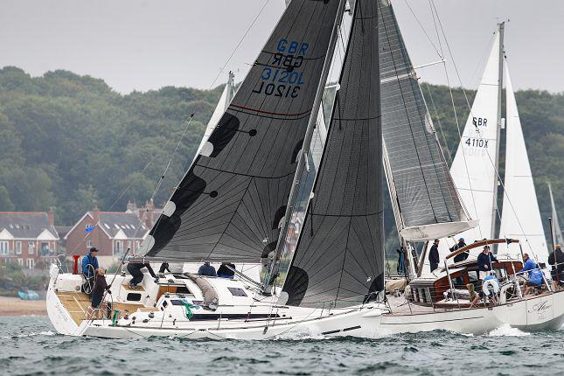

“Stormcloud is a piece of aging French Tupperware crewed by a bunch of elderly Corinthians,” laughs William Farmer of their 2012 Dufour 36. “We sail out of the Royal Southern YC and have even won a few races on the days when the good guys don’t turn up or they break something big!

“We have some nice Sanders Sails that help a lot, but the boat is more cruiser-racer than racer-cruiser. We will downsize the wine cellar for the Fastnet, but the crew are allowed pillows and comfy mattresses.  
  
“The boat is owned by three co-owners and used for family cruising as well as club racing, plus a few JOG and RORC events.

**NORTHERN IRELAND**

**First time for father and son skipper duo with young crew** *Elixir, Mat1010, Ryan Wilson – IRC3*

Northern Ireland

Yacht Club: Carrickfergus Sailing Club / Quoile Yacht Club

Elixir is a 2014 build, and new to the Wilson family since late 2023. This father and son skipper duo, Ryan Wilson (32) and Brian Wilson (65), will be sailing with friends from when Ryan was a Topper/Laser sailor, with a few extras they’ve met along the way. It will be the second Fastnet for Ryan, first for the yacht. 2 crew have done 2 Fastnets, and the rest have done none.

This is their third yacht together, and the first capable of offshore racing. It will be their second 600 mile race after narrowly missing a podium spot in class in the Round Ireland last year (2 minutes). Second for me, first for the yacht. 2 crew have done 2 and the rest have done 0.

The crew will be a mix of northern Irish, Scottish and Australian:

Ryan Wilson (32) Skipper, Brian Wilson (65) Skipper, Peter Cameron (32) Navigator, Chris Kilgour (30) Scottish

Daniel Corbett (19), Katie Nelson (22), Andrea Davey (24) AUS. William Findlay (30)

Ryan comments: “The Australian crew member, Andrea Davey, joined us last year for Round Ireland after we had a last-minute drop out and needed someone with two weeks’ notice. We met at the airport the night before the race and she gelled instantly with the rest of the crew.

Everyone does a bit of everything on board! Professions onboard include: Video Producer, Master Mariner, Naval architect, Civil Engineer, Marine Biologist, Technology teacher, Naval architect student and a CYCA staff member.”

As to their aspirations: “We will be aiming for Top 10 in class, top 20% overall. I think, for us, a highlight will be competing with some of the best crews and boats in the world, as a relatively small budget. If conditions suit us, we know we have just as much a chance as anyone else.”

**@elixirsailing**

**Contact: Ryan Wilson - Info@ryanwilsonvideo.com**

**WALES**

**Poignant moment at Fastnet for Jezebel**

*Jezebel, J111, Cris Miles – IRC2*

Conwy, N. Wales

Yacht Clubs: North Wales Cruising Club (Conwy) and Pwllheli Sailing Club

This will be the first Fastnet for Cris Miles of BOOM Sail, Power and Race Training, a twice veteran of the Round Ireland Race, along with two of his crew members.

Now a professional sailor and instructor (although, in his words, “not in the league of the Vendee Globe heros!”), Cris was a long-time dinghy racer, with successes at national and international level. He is a veteran of many ISORA races, Scottish Islands Peaks Race, Three Peaks Yacht Race.

A good number of the crew have previously chartered Jezebel for the Three Peaks Yacht Race and Cork Week:

Karl Quirk - retired - Co-skipper, Roger Ward - Builder

James Hayward – CEO, Ben Westcott - Carbon offset consultant – Bow, Jeremy Robinson - Colonel

Alex McKenzie – Consultant, Rob Whitmore-Jones - Joiner

Cris comments: “An exemplary bunch of guys with military background – professions are on a need-to-know basis! - I feel privileged to have been chosen to lead them on such adventures. While this is a commercial operation, I regard each and everyone onboard a real friend having been through some tough events together.”

The crew are well experienced and are about as strong a team as we have ever built. One of our crew will be scattering the ashes of his father at the Fastnet as per his wishes.

We’re looking forward to some close (very close) racing in the Solent. Achieving top half of the fleet would represent a decent result, but, first and foremost, finishing with everyone safe.”

**Contact: Cris Miles - BOOM Sail, Power and Race Training -** [**info@boomsailing.co.uk**](mailto:info@boomsailing.co.uk)

**IRELAND**

**Descendants of 1925 Fastnet Race – Now 5th generation family affair**

*Jalapeno, J109, James Donegan, Cork, Ireland - IRC 4*

Yacht Clubs: RORC & Kinsale Yacht Club, Royal Cork YC.

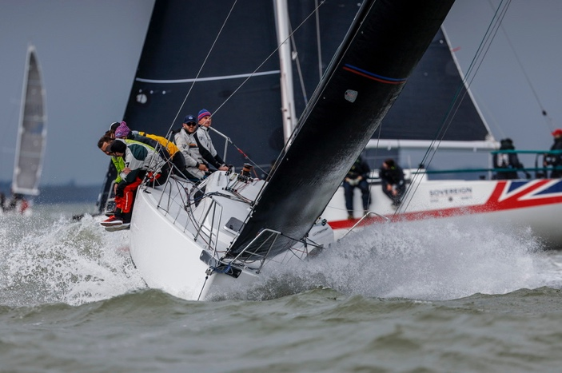Five family members, directly related to Harry Donegan who raced aboard 1895 Gull in the 1925 Fastnet Race, will be competing on the J109 Jalapeno. “Four generations of our family have completed in the Rolex Fastnet Race, and now with the fifth generation taking part - including the first female of the family since first entering in 1925 - this race is very special,” says James Donegan who first took part in 1986. Henry Donegan was his great-great-grandfather.

Instagram: <https://www.instagram.com/jalapenoj109/>

Media contact: Alice Donegan, Email: [alicedonegan02@gmail.com](mailto:alicedonegan02@gmail.com).

PRESS CONTACT:

#RolexFastnetRace <http://www.rolexfastnetrace.com/>

**RORC PRESS OFFICER:**

Trish Jenkins - Press Officer - Rolex Fastnet Race  
M: +44 (0) 7880 518 689 (+ WhatsApp)

E: [press@rorc.org](mailto:press@rorc.org)